24.62: a) 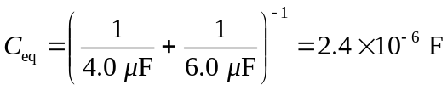
and
b) Disconnecting them from the voltage source and reconnecting them to themselves we must have equal potential difference, and the sum of their charges must be the sum of the original charges:
